**Microsoft Azure**

**[Nilavembu Herbs]**

**[Azure Case Study]**

**Kamaljeet Kaur**

**Clouds Operation Engineer- Batch 1**

**This document contains Screenshots of my Workings in Azure Portal.**

**(Working in South East Asia region SEA)**

* **Creating Resource Group.**
* IN SEA region.

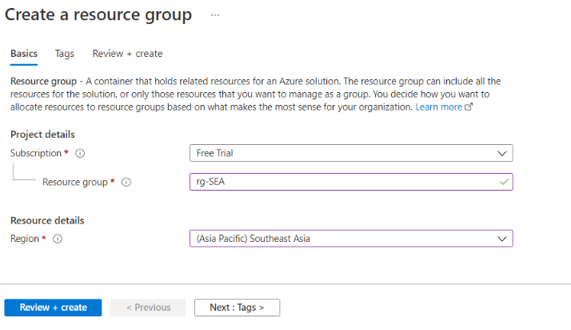

* **Creating Virtual Network:**
* **For SEA region which contains two subnets.**

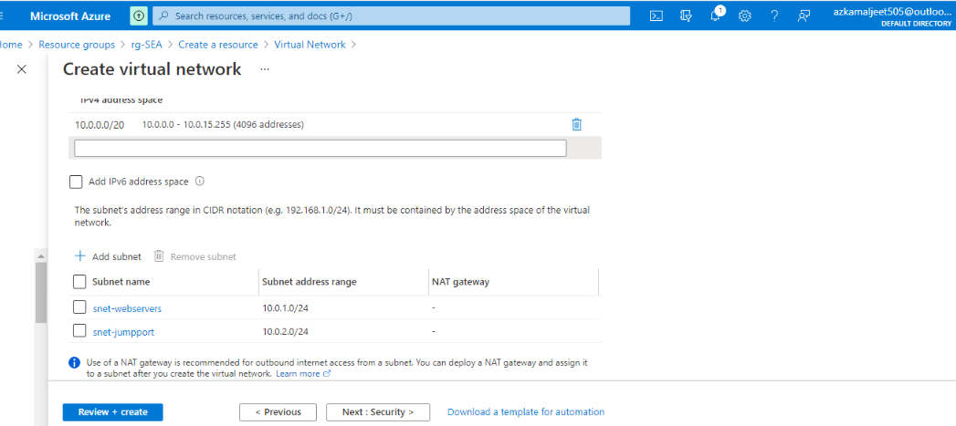

* **Creating two subnets for SEA region.**
* **One for SEA webservers**
* **And other for jump port.**

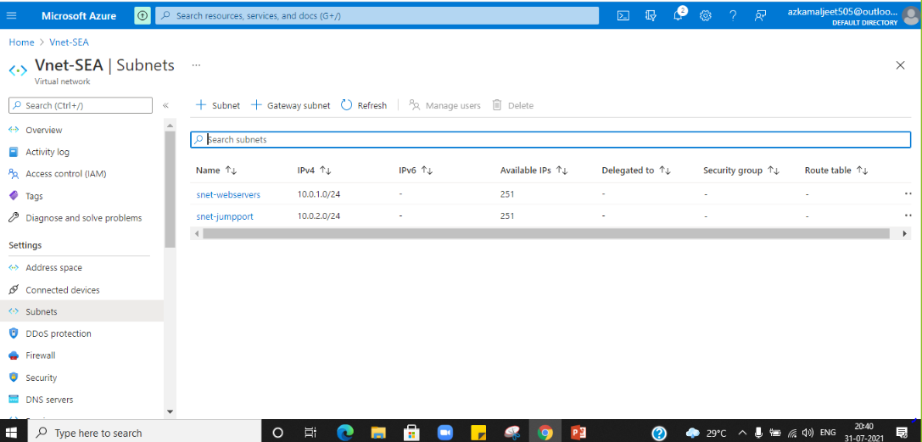

* **Creating Availability set.**
* **With 2 fault domains so that we can achieve high availability of 99.95 %.**

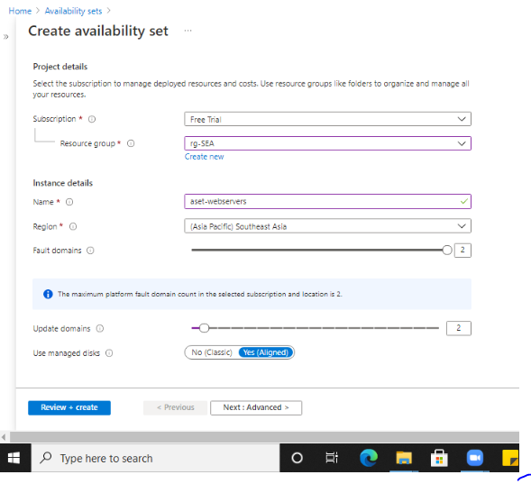

* **Creating NSG**

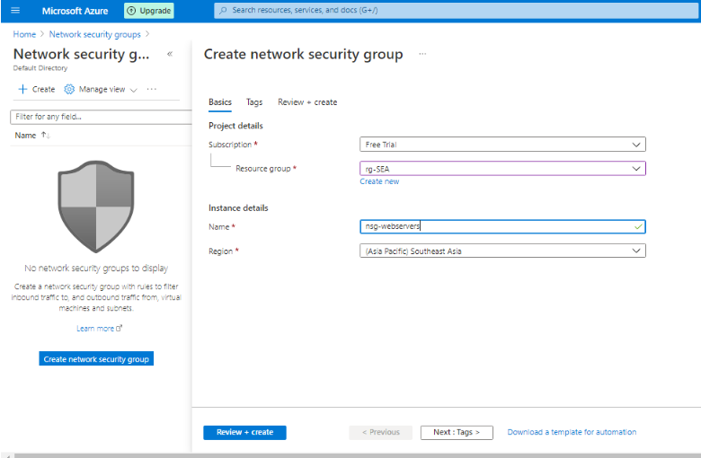

* **Creating Virtual Machine for SEA region.(webserver1-SEA)**

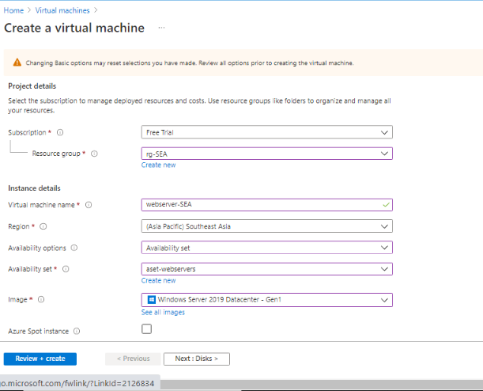

* **Setting OS disk type to Standard SSD.**

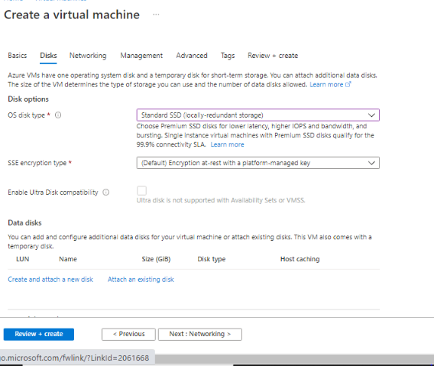

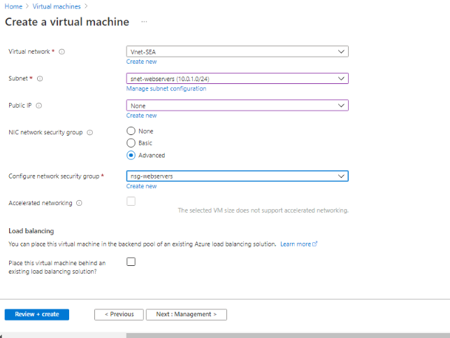

* **Creating Virtual Machine for SEA region. (webserver2-SEA)**

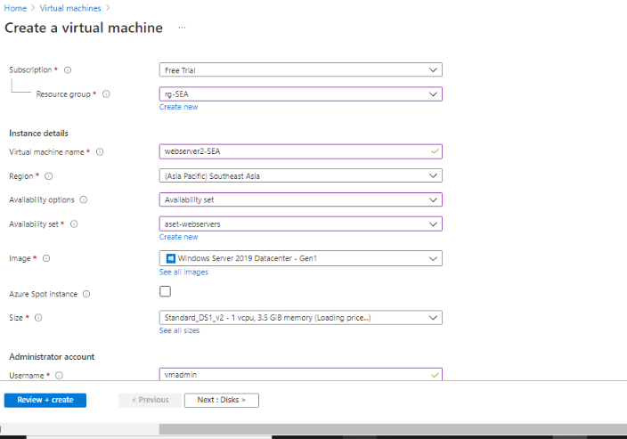

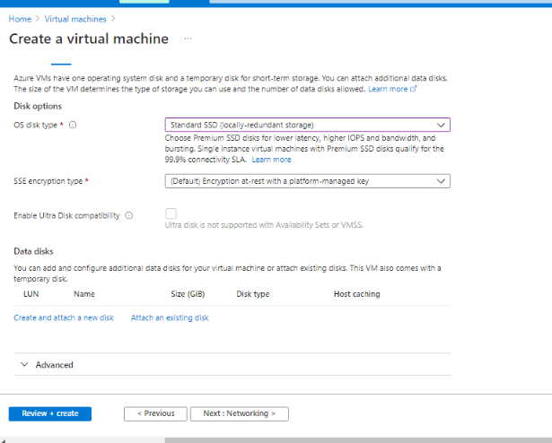

* **Creating a VM in SEA region. (jumpserver1-SEA)**

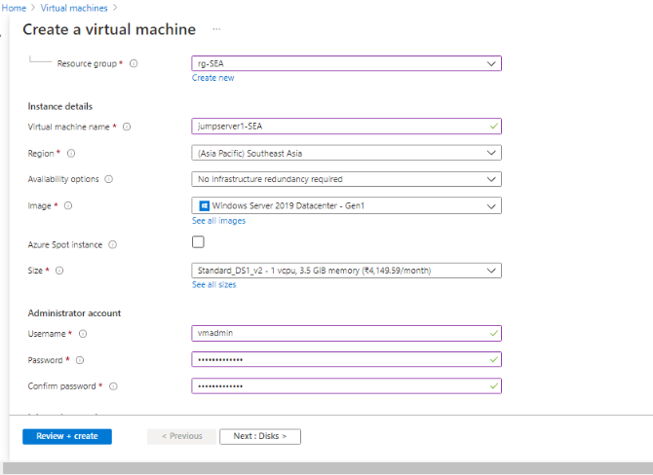

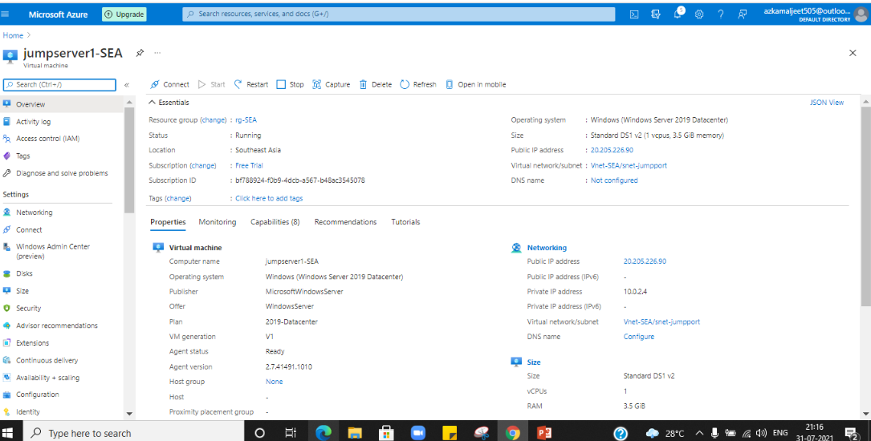

* **Creating load balancer.**

**For secuirity purpose as it will control the traffic and also gives client affinity.**

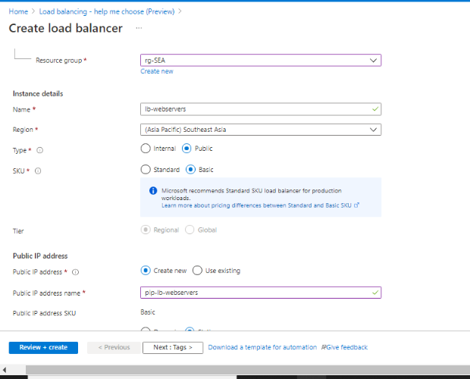

**We have used a basic load balancer as we have a few servers, so our purpose is achieved.**

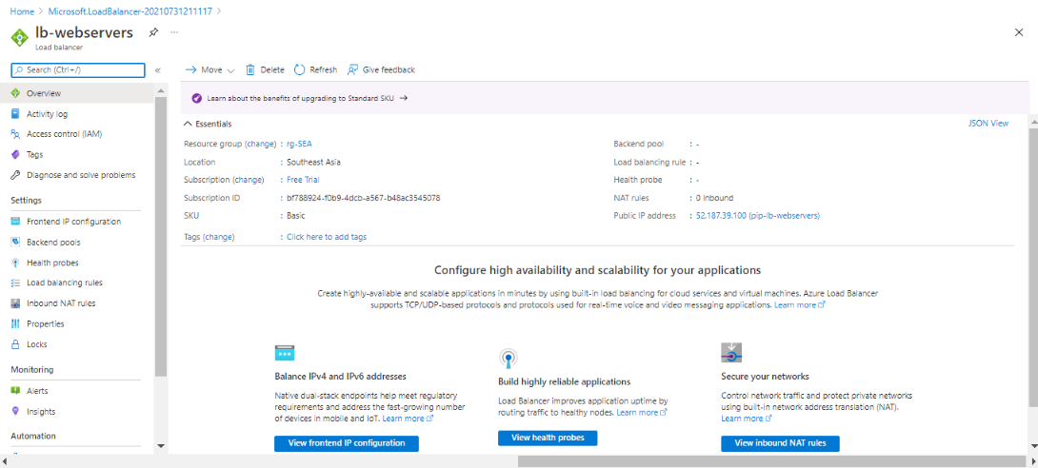

* **Adding backend pool in load balancer**

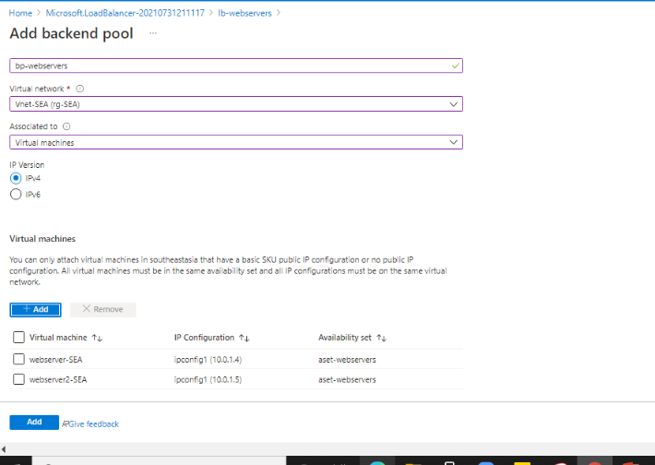

* **Adding load balancing rule**

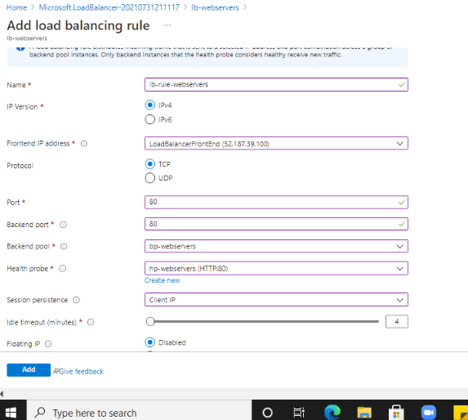

* **Adding inbound NAT rule.**

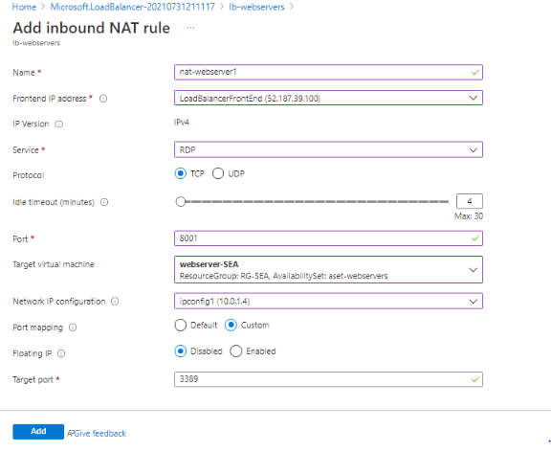

* **Assigned NSG to subnet.**

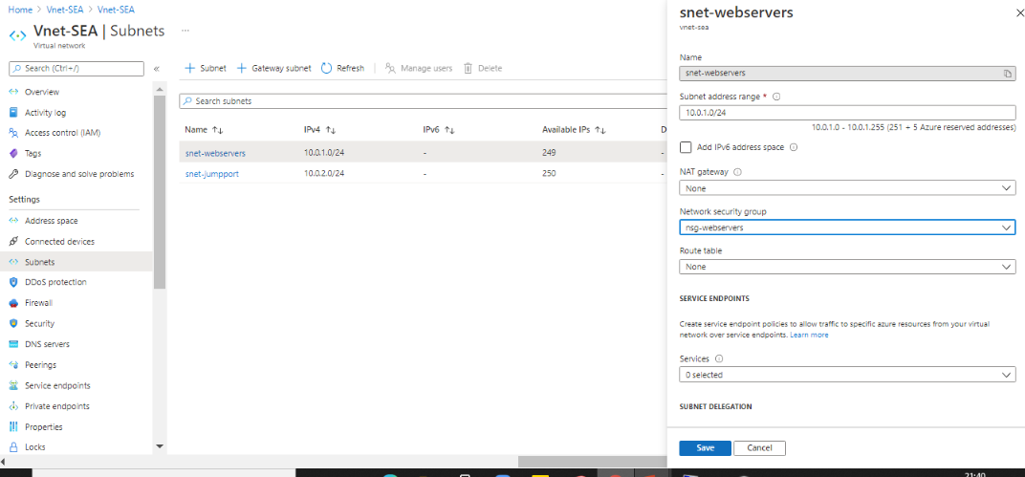

* **Adding Inbound Security Rules.**

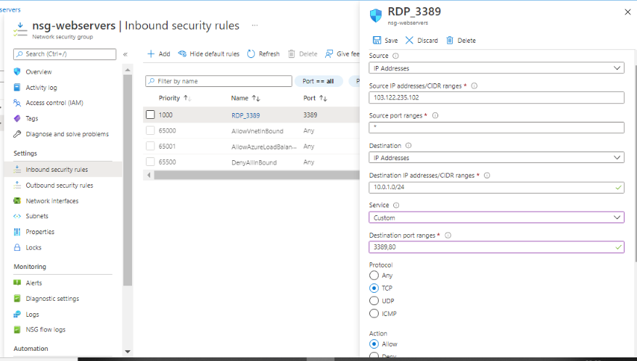

* **Accessing webserver using Inbound NAT rule.**

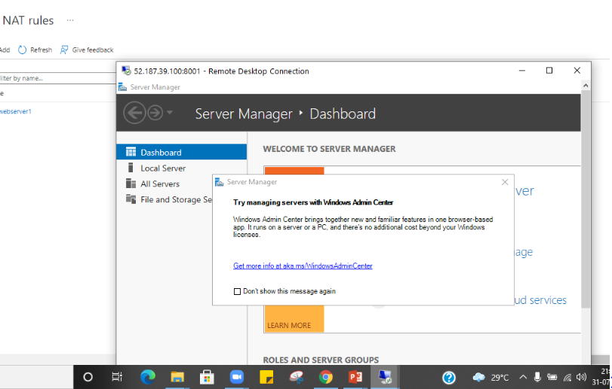

* **Install IIS in VM1 to make it a webserver**

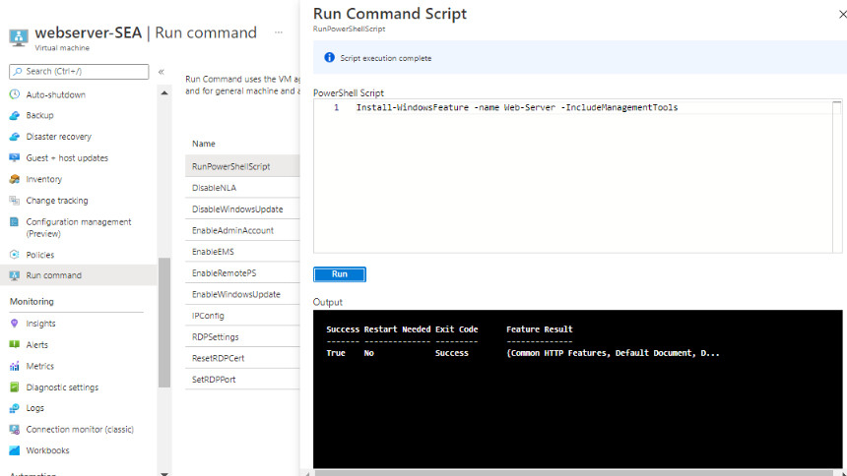

* **Install IIS in VM2 to make it a webserver**

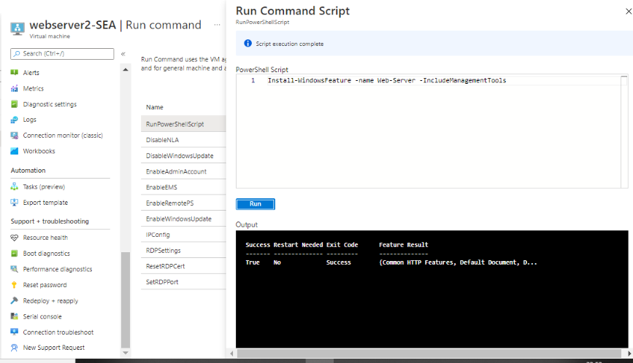

* **Enabling backup**

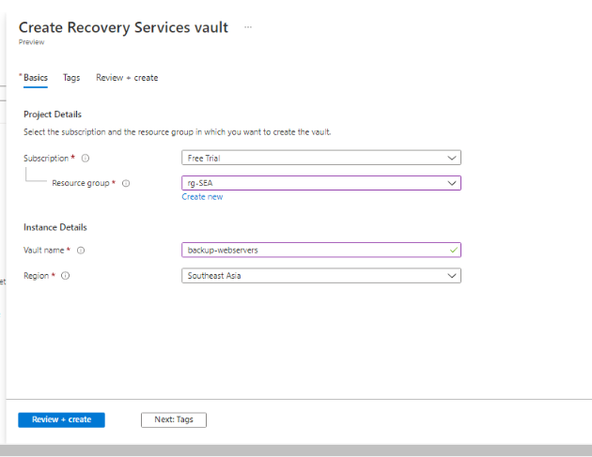

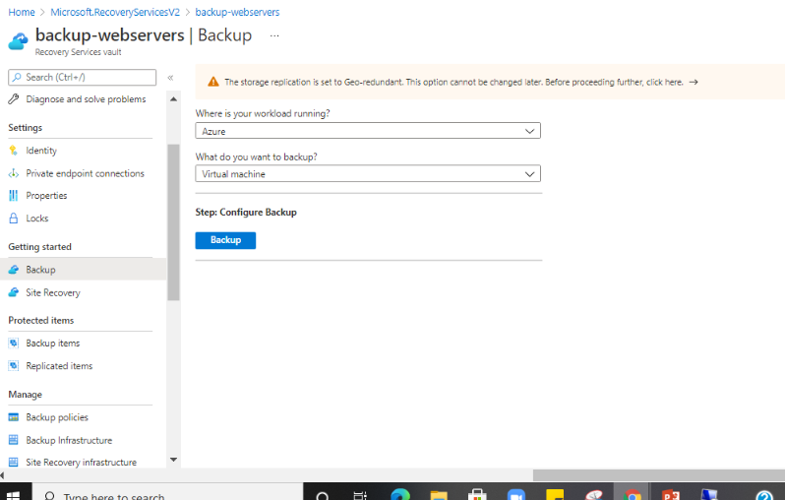

* **Configuring backup and creating a backup policy**

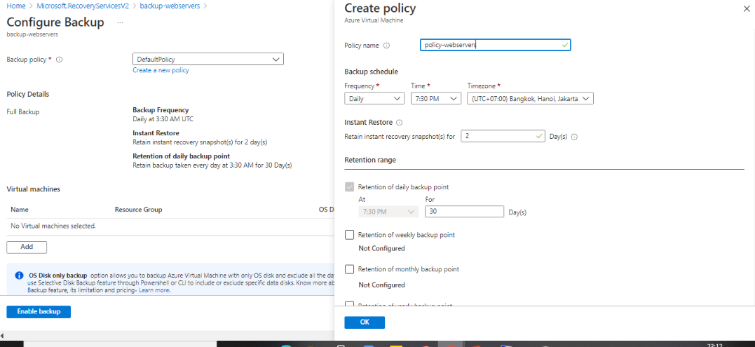

* **Backup enabled for both the webservers in SEA region**

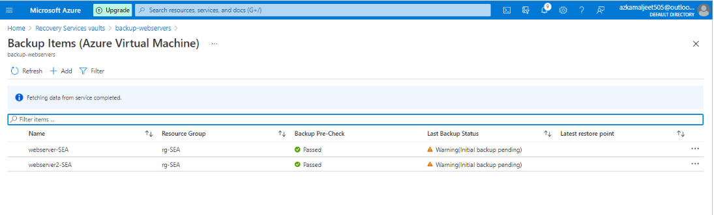

* **Creating alert rule.**

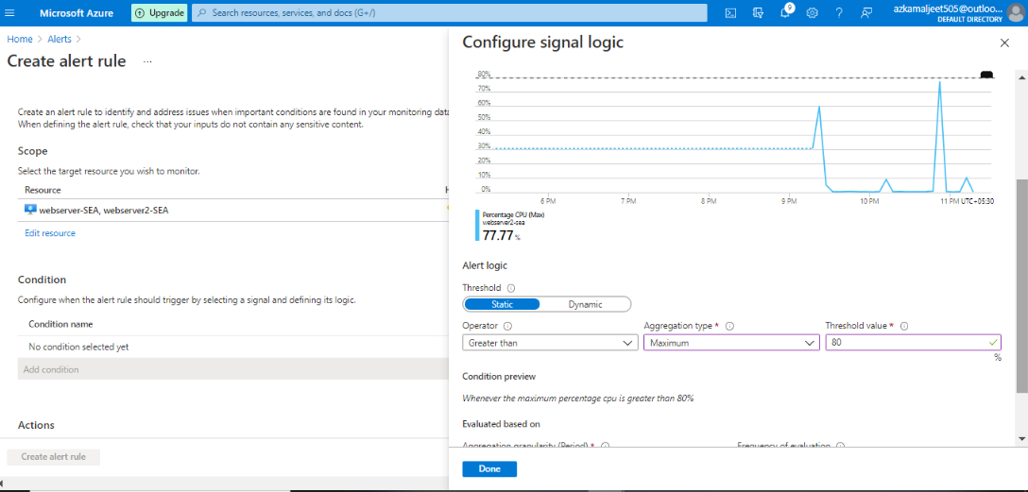

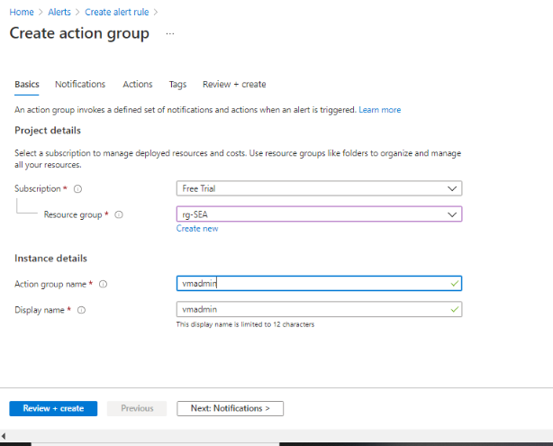

* **Setting up the mode to receive alerts.**

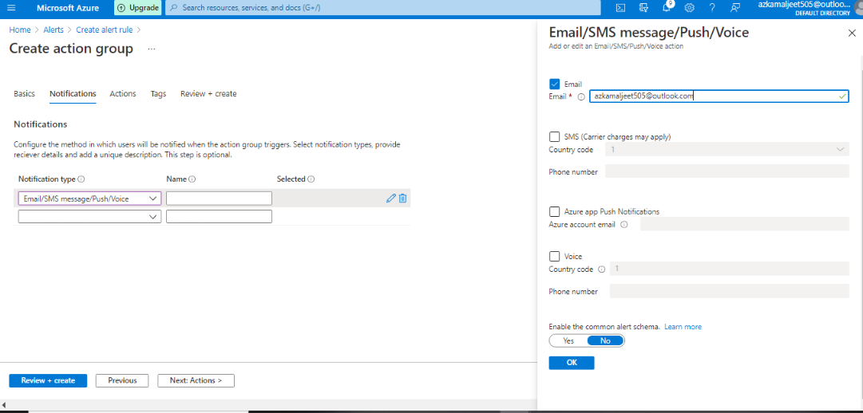

* **Creating alert rule**

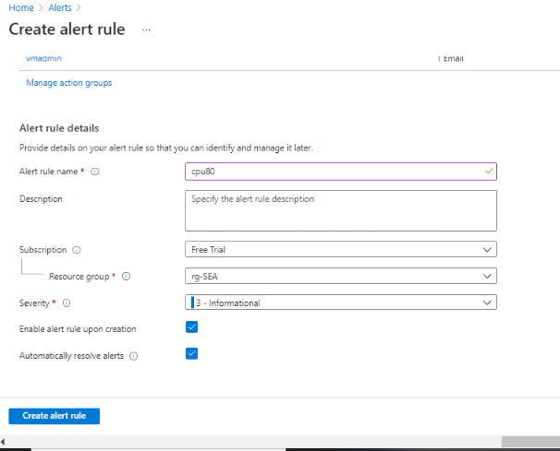

* **Alert rule been created successfully and the email address has been linked to receive notifications.**

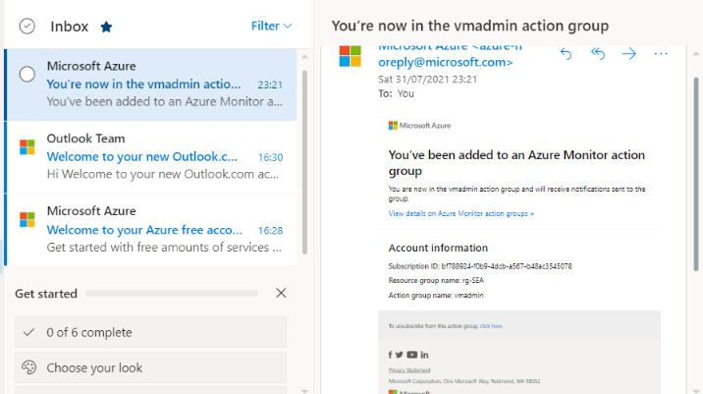

* **Alert Mail received on meeting the conditions created in alert rule.**

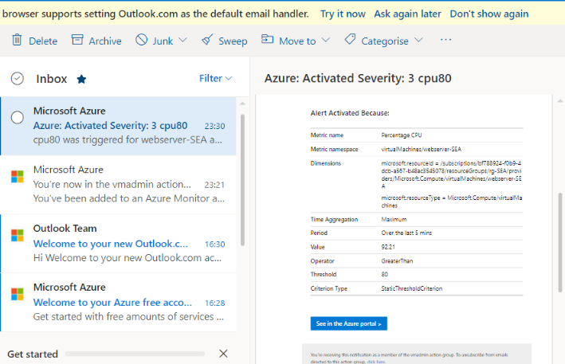

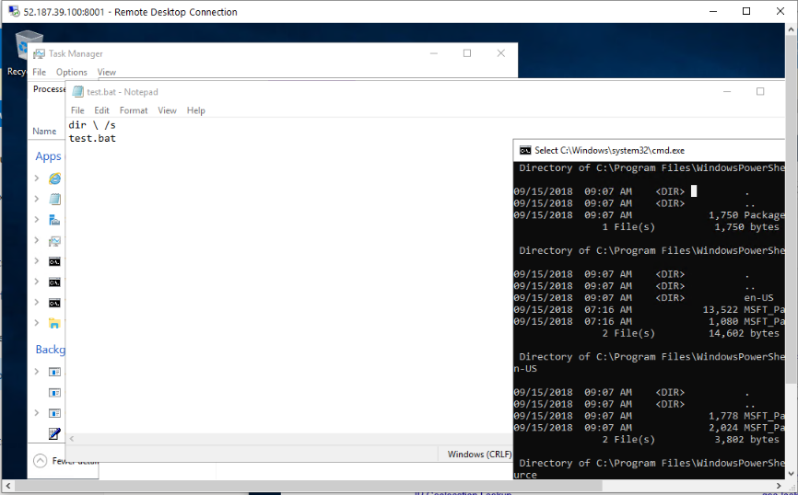

**(Working in East US region EUS)**

* **Creating a resource group in EUS region.**

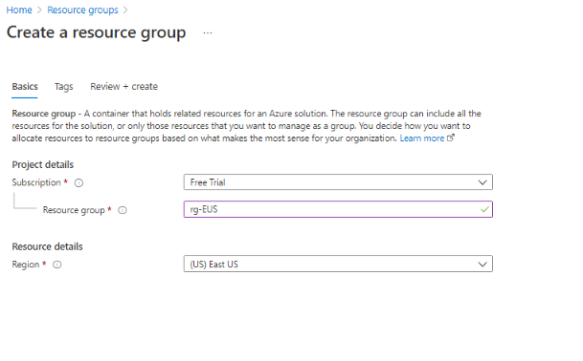

* **Creating a Virtual Network in EUS region.**

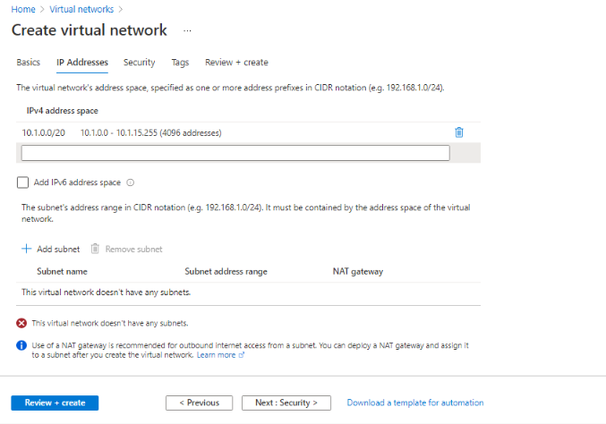

* **Creating a virtual machine in EUS region.**

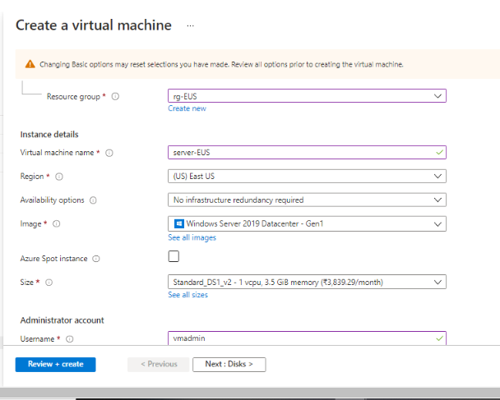

* **Setting up the OS disk size to SSD.**

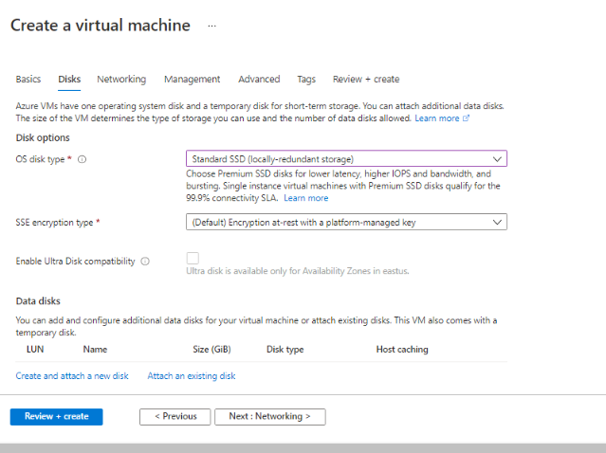

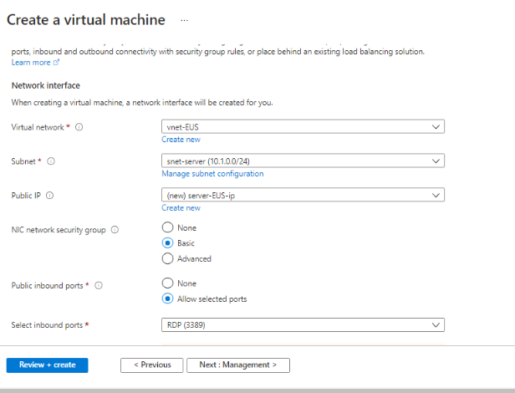

* **Establishing secure Connection to SEA-EUS Azure sites through peering.**

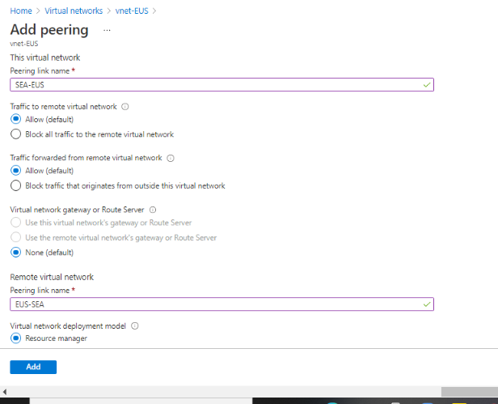

* **Secured connection is established. Peering done successfully.**

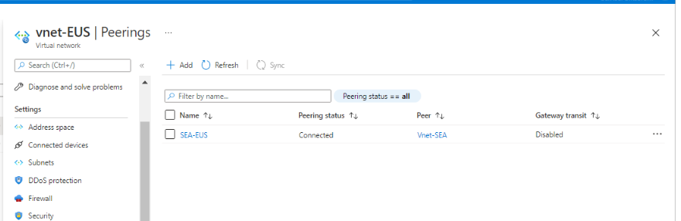

* **servers are reachable with internal ip addresses.**

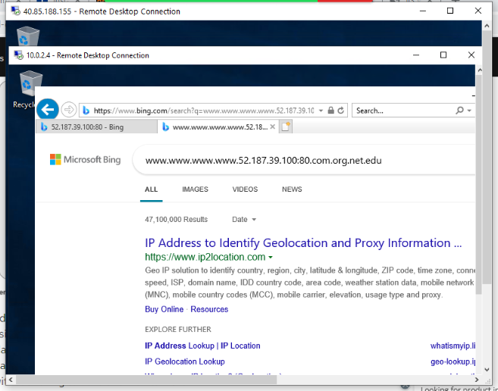

**Storage Requirement:**

* **Creating storage account for EUS region with zone-redundant storage.**

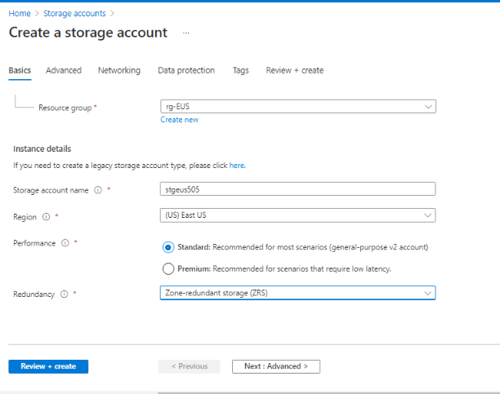

* **Creating secured access for Storage account in EUS region.**

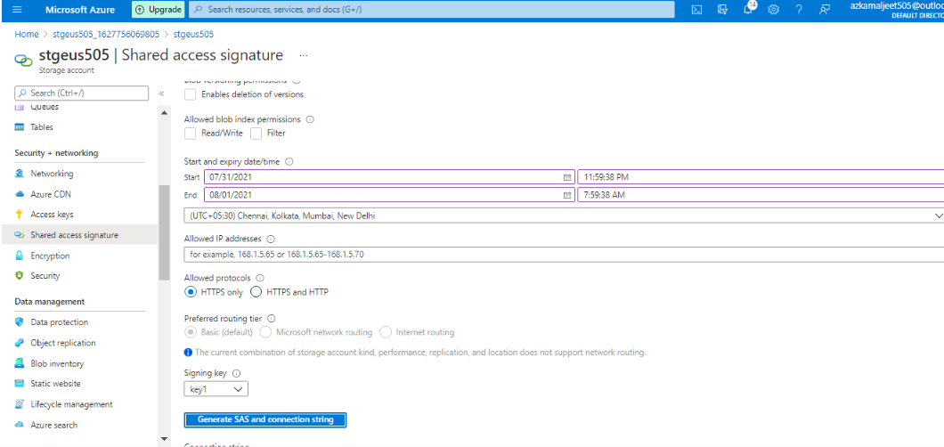

* **Creating Files share.**

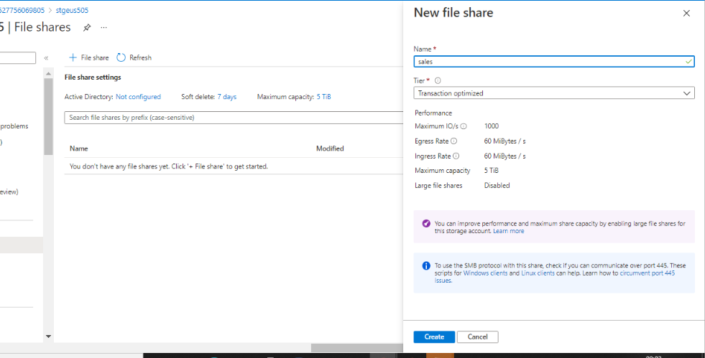

* **Mount the Drive**

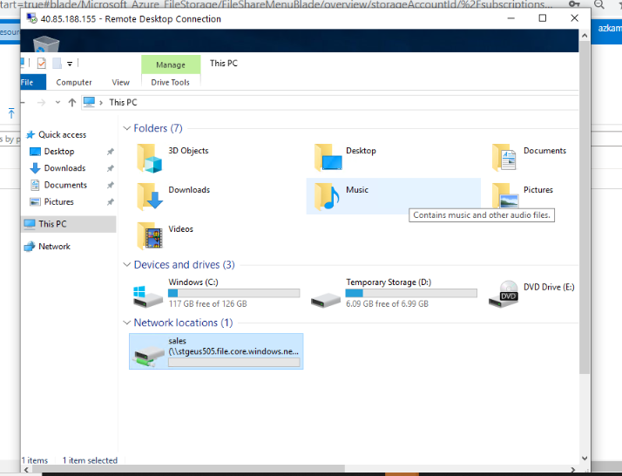

* **Creating storage account in SEA region with Geo-redundant storage to be used in multiple azure data centre failure.**

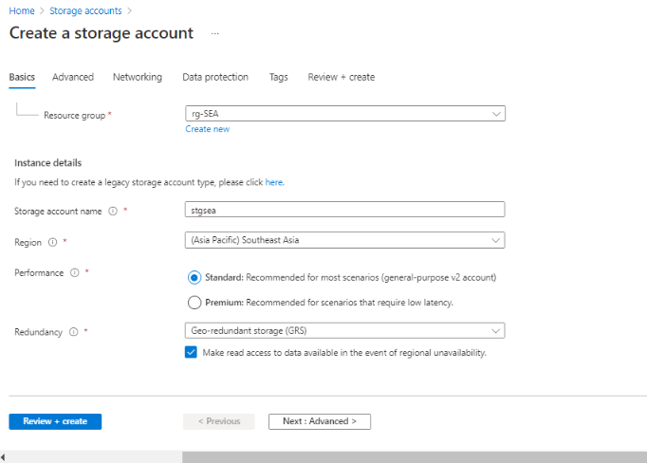

**Azure Resource Management:**

* **Creating VM admin user to monitor all VM in subscription.**

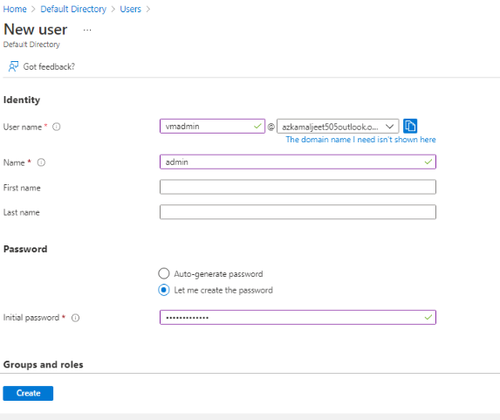

* **Creating Backup admin user, to manage backup only in EUS servers.**

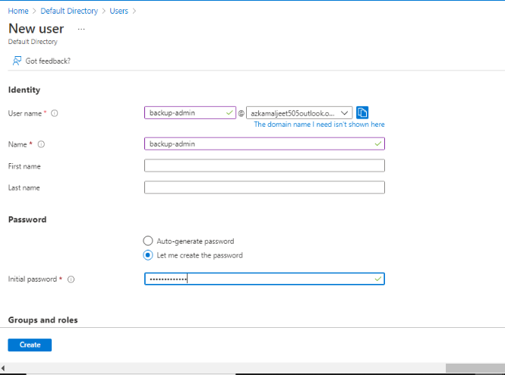

* **Adding roles to the users created.**

